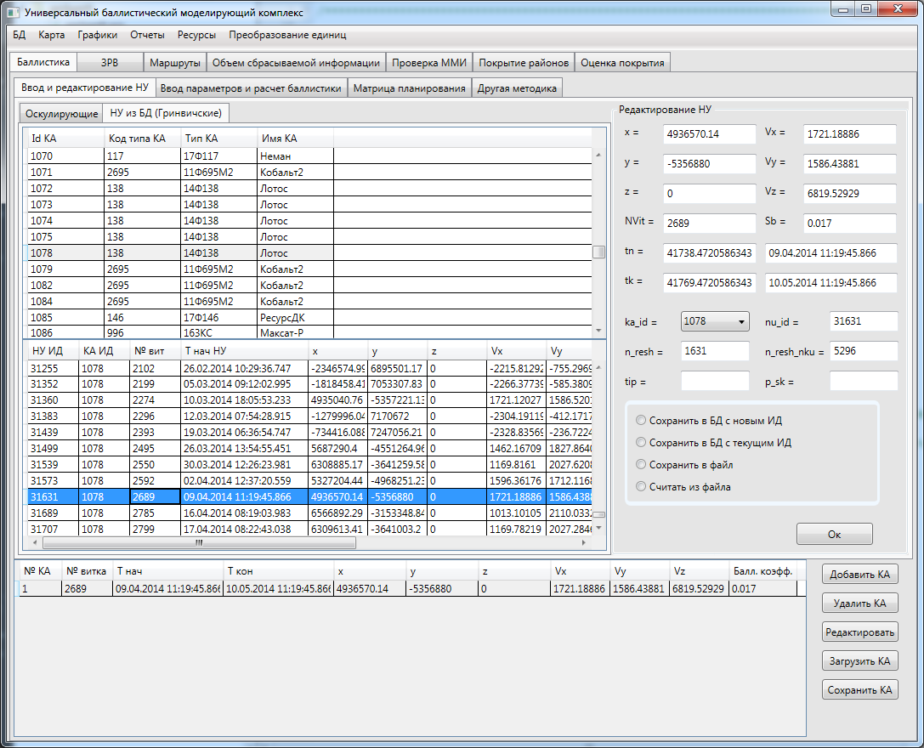

|  |  |  |  |  |  |  |  |  |  |  |
| --- | --- | --- | --- | --- | --- | --- | --- | --- | --- | --- |
| 1 | 2689 | 09.04.2014 11:19:45.866 | 10.05.2014 11:19:45.866 | 4936570.14 | -5356880 | 0 | 1721.18886 | 1586.43881 | 6819.52929 | 0.017 |

Ka_id 1078 **nu_id 31631** n_resh 1631 n_resh_nku 5296

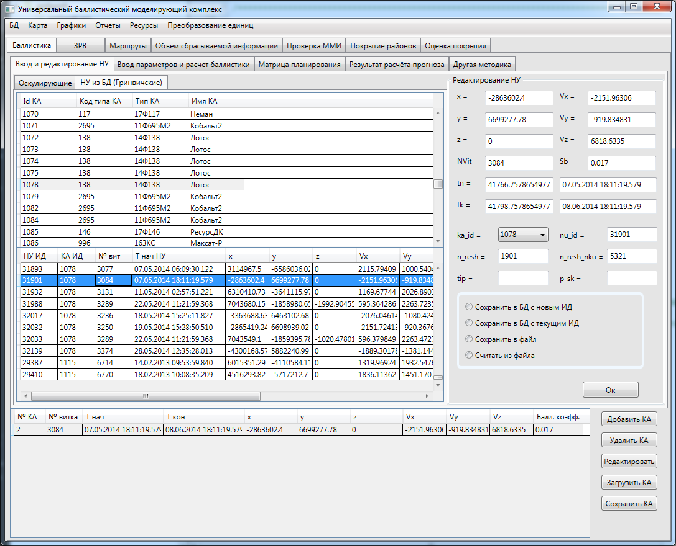

|  |  |  |  |  |  |  |  |  |  |  |
| --- | --- | --- | --- | --- | --- | --- | --- | --- | --- | --- |
| 2 | 3084 | 07.05.2014 18:11:19.579 | 08.06.2014 18:11:19.579 | -2863602.4 | 6699277.78 | 0 | -2151.96306 | -919.834831 | 6818.6335 | 0.017 |

Ka_id 1078 **nu_id 31901** n_resh 1901 n_resh_nku 5321